EXPERIMENTAL

***1. Building and Assessing Spectrometer***

A fluorescence spectrometer was assembled on a breadboard using a 375 nm UV LED (2.5 mW), 25.4 mm Plano-convex lens, cuvette holder, 420 nm long pass filter, and detector in the arrangement shown in Figure 1. The detector was fitted perpendicular to the lens and LED, to prevent detection of reflected photons or those passing through the sample, and record only those from fluorescence as photons are emitted in all directions. Optimal spacing of the lens and LED was determined by placing paper where the light would focus The dynamic range of the spectrometer was found using different concentrations of quinine. An initial stock solution of 1 mM quinine in 0.05M H2SO4 was made up and diluted to give lower concentrations, placing 1 mL of each concentration into the cuvette to be measured, to determine dynamic range of the spectrometer. UV light from the LED was passed through each sample and the resulting intensity was recorded using a Raspberry Pi.

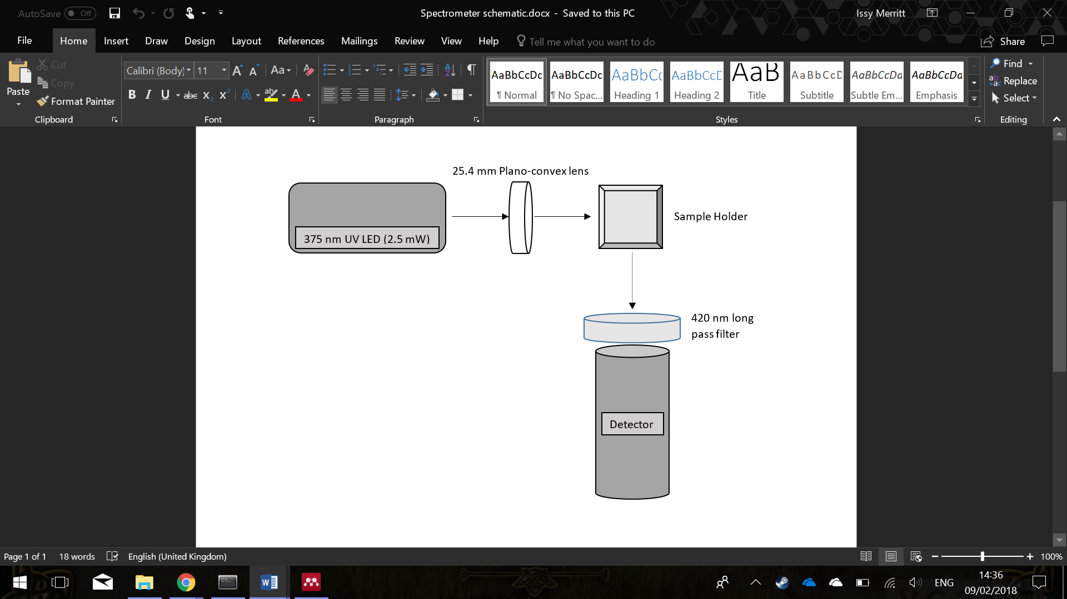

Figure : Spectrometer Setup

|  |  |  |  |  |  |
| --- | --- | --- | --- | --- | --- |
| Sensitivity | Background | | LOD | LOQ | LOL |
| 469.6  (±20.9) | 6.54  (±2.26) | | 0.02 mM | 0.03 mM | 0.2 mM |
| Dynamic Range | | 0.03 – 0.2 mM | | | |

***2. Preparation of Stock Solutions***

Table : Determined Spectrometer Properties

A 1 L stock buffer solution was made up using K2HPO4 and KH2PO4. Stock solutions of BSA, ANS, urea and GmCl (guanidinium chloride) were made up. For a 1 mM BSA solution, 0.333 g BSA was dissolved in 5 mL buffer solution. For a 1 mM ANS solution, 0.0306 g ANS was dissolved in 25 mL DMSO and 75 mL buffer solution. A 10 M urea solution was composed of 6.01 g urea in 10 mL buffer solution. A 6 M solution of GmCl was made up using 5.7318 g GmCl in 10 mL buffer solution.

***3. Protein Unfolding Experiments***

*a) Determining the number of binding sites*

Using the stock solutions of buffer, ANS and BSA, 1 mL solutions of differing concentrations were made up in cuvettes. Concentrations of ANS were ranging from 0 to 0.36 mM in increments of 0.02 mM. These were added to BSA concentrations of 0.01 mM. The cuvettes were made up to 1 mL using the buffer solution. The error associated with the mechanical pipette for BSA was ± 2% and the error associated with the mechanical pipette for ANS was ± 1.6%. The data was found to not contain a linear region as saturation of binding sites was immediate, therefore concentration of BSA was increased to 0.05 mM.

*b) Determining the Gibbs’ Free Energy change of unfolding*

*i) Urea*

Different concentrations of urea solutions in the range 0-1 mM in increments of 0.1 mM were made up to 1 mL using BSA, urea, ANS and buffer stock solutions. The concentrations of BSA and ANS were kept constant at 0.05 mM. Again the errors were small at ± 2%. The solutions were put through the fluorescence spectrometer and the results collected.

*ii) Guanadinium Chloride*

A similar method was used with Guanadinium Chloride as solutions of different GmCl concentrations in the range 0-6 mM in 0.6 mM increments were made up with the BSA, GmCl, ANS and buffer solutions. The BSA and ANS concentrations were kept constant at 0.05 mM and the errors of the solutions were 2%. The solutions were placed in the fluorescence spectrometer and data was collected.

RESULTS AND DISCUSSION

*1. Using Quinine to determine dynamic concentration range and sensitivity of the spectrometer*

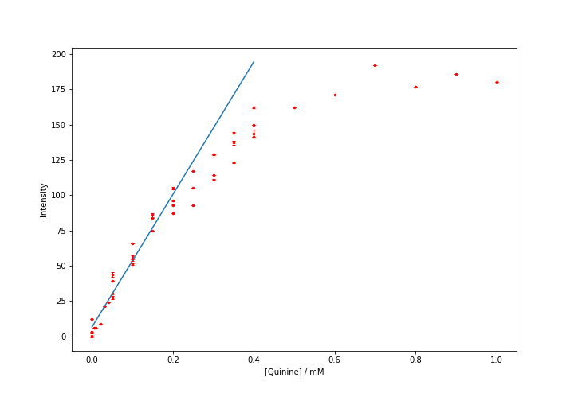

Figure : Fluorescence Intensity with Increasing [Quinine]

To determine the limitations of the spectrometer assembled, a calibration curve (Figure 2) was plotted from measurements of intensity with varying quinine concentration. Quinine was chosen for this calibration as it has an excitation peak at 350 nm and therefore will be excited by the 375nm LED used.1 It also has emission at a point similar to ANS at 450 nm- ANS emission is at roughly 475 nm.2 A linear fit was carried out using the data from the visibly linear region of the graph, giving a line of form y = mx + c, where the gradient (m) is the sensitivity of the spectrometer and the intercept (y) is the background noise. These properties and associated errors are shown in Table 1.

The linear fit can also be used to determine the limit of linearity (LOL)- the point to which the calibration curve remains linear. From a residuals plot (Figure 3) of the data against the linear fit, the residuals become significant above 0.2 mM and so this is the LOL. The limit of detection (LOD) is the lowest concentration of analyte that can be detected, this can be found from data inspection- the first concentration to give an emission higher than background is 0.02 mM and so *this is the LOD.*

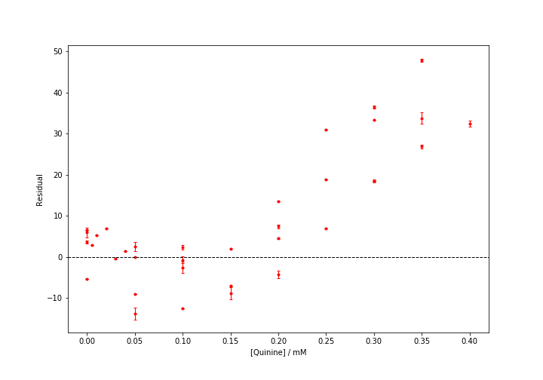

Figure : Residuals of Linear fit to Calibration Curve

*The limit of quantitation (LOQ) is the lowest concentration of analyte that can be accurately analysed. While this is a less defined property, it is often taken as the first concentration at which the data is accurate to 1 significant figure. Using the background and error associated with this (found using linear fit on python), the intensity of fluorescence at 0.02 mM can vary from 0.2 to 4.72 (different to 1s.f.). The intensity of fluorescence at 0.03 mM can vary from 18.74 to 23.26 and so it is accurate to 1 s.f. and is the LOQ. The dynamic range of the spectrometer is between the LOQ and the LOL, and therefore is from 0.03 – 0.2 mM.*

*2. Protein Unfolding Experiments*

*a) Determining the number of Binding Sites*

*b) Determining the Gibbs’ Free Energy change of unfolding*

REFERENCES

1. Sawyer, D. T., Heineman, W. R. & Beebe, J. M. Characterization of Quinine and Its Determination.

2. Schö, E. *et al.* Structural basis for the interaction of the fluorescence probe 8-anilino-1-naphthalene sulfonate (ANS) with the antibiotic target MurA.